Module

📌 Definition:
# Source: AI Source: Provided by: [Data Path: Persons Table -> ID Column: 1, Name_En Column: Motasem Essam] -> From: [Chatgpt (GPT‑5 Mini)] on [12/9/2025]
A module is a self-contained unit of code that groups related functions, classes, or data together to perform a specific task.
It encapsulates functionality so it can be reused, maintained, and organized independently.
module can include any of the following:
• Functions – reusable blocks of code that perform tasks
• Classes – encapsulate data and behavior
• Variables/constants – store values used by the module
• Sub-modules – smaller modules or packages inside a larger module
• Optional initialization code – code that runs when the module is imported

🧠 Simple idea:
# Source: AI Source: Provided by: [Data Path: Persons Table -> ID Column: 1, Name_En Column: Motasem Essam] -> From: [Chatgpt (GPT‑5 Mini)] on [12/9/2025]
Think of a module as a “box of related tools” — you can use the tools without needing to know all the details inside.

⚙️ Key Characteristics:
- 📦 Encapsulated – Contains related code and data
- 🔄 Reusable – Can be used in multiple programs
- 🧩 Independent – Works on its own but can interact with other modules
- 🛠️ Organized – Makes large programs easier to manage

📌 Examples:
# Source: AI Source: Provided by: [Data Path: Persons Table -> ID Column: 1, Name_En Column: Motasem Essam] -> From: [Chatgpt (GPT‑5 Mini)] on [12/9/2025]
- Python module: math, random
- Java module: java.util, java.io
- C++ module: .cpp file with related functions and classes

🧩 Python Module Example
# Source: AI Source: Provided by: [Data Path: Persons Table -> ID Column: 1, Name_En Column: Motasem Essam] -> From: [Chatgpt (GPT‑5 Mini)] on [12/9/2025]
Step 1: Create a module
Create a file named calculator.py:
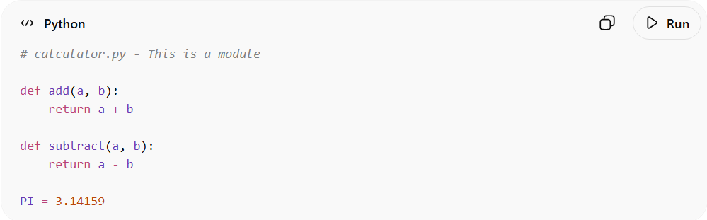
# calculator.py - This is a module

def add(a, b):
return a + b

def subtract(a, b):
return a - b

PI = 3.14159
- ✅ Contains functions (add, subtract) and a constant (PI)
- ✅ Encapsulated, self-contained, reusable

Step 2: Use the module in another program
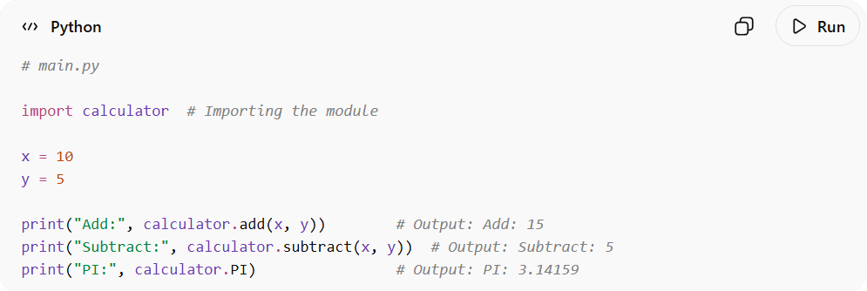
Create a file named main.py:
# main.py

import calculator # Importing the module

x = 10
y = 5

print("Add:", calculator.add(x, y)) # Output: Add: 15
print("Subtract:", calculator.subtract(x, y)) # Output: Subtract: 5
print("PI:", calculator.PI) # Output: PI: 3.14159
- ✅ main.py doesn’t know the internals of calculator.py
- ✅ We just use its interface

🧠 Key Idea:
# Source: AI Source: Provided by: [Data Path: Persons Table -> ID Column: 1, Name_En Column: Motasem Essam] -> From: [Chatgpt (GPT‑5 Mini)] on [12/9/2025]
- A module is like a toolbox: you don’t need to know how each tool works, you just use it.
- Makes code organized, reusable, and maintainable.

🎯 Why use modules?
# Source: AI Source: Provided by: [Data Path: Persons Table -> ID Column: 1, Name_En Column: Motasem Essam] -> From: [Chatgpt (GPT‑5 Mini)] on [12/9/2025]
- Improves readability and maintainability
- Promotes code reuse
- Supports team collaboration by dividing work into smaller parts

